The UMBC Department of Education presents
UMBC’s Eleventh Annual Arts Integration Conference
Saturday, February 18th, 2017
8:45-3:00 (8:15 check-in/breakfast)

Makers, Shakers & Boundary Breakers
Blending Curriculum & Creativity through Arts Integration

REGISTRATION FORM

Check all that apply:
___Conference registration………………………………………………………………………….…….…………… $30.00
___Early Bird Special (through January 27th, 2017)…….……………………………………...….……....$25.00
___UMBC-PDS teacher, student, or presenter……………………..……….…..……Registration fee waived
___20% discount if part of a school team of 3 or more*..................................... -20% ________
*SCHOOL TEAMS: PLEASE SEND REGISTRATION FORMS TOGETHER
Subtotal ____________
___Optional afternoon field trip to MD Science Center (nonrefundable)...............................$5.00

TOTAL AMOUNT ENCLOSED _________

Name

Address

City State Zip

School or Institution

Email Phone

Make checks payable to: UMBC
Return registration form to: Further information:
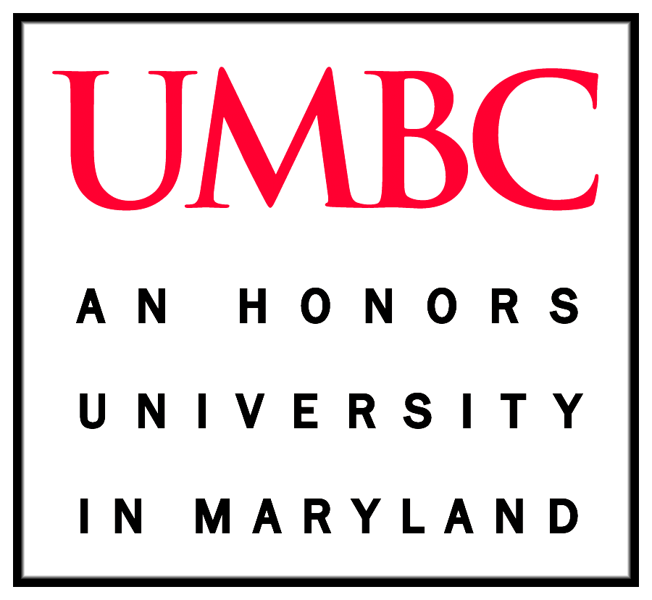
Arts Integration Conference Rebecca Weisberg
UMBC Department of Education rewe1@umbc.edu 1000 Hilltop Circle http://education.umbc.edu/aiconference17
Baltimore, MD 21250
Or fax to: 410-455-3986

